SUBCOURSE EDITION
OD0472 7

PRINCIPLES OF GUNNER'S PRIMARY SIGHT (GPS)
AND THERMAL SIGHT -M1 TANK



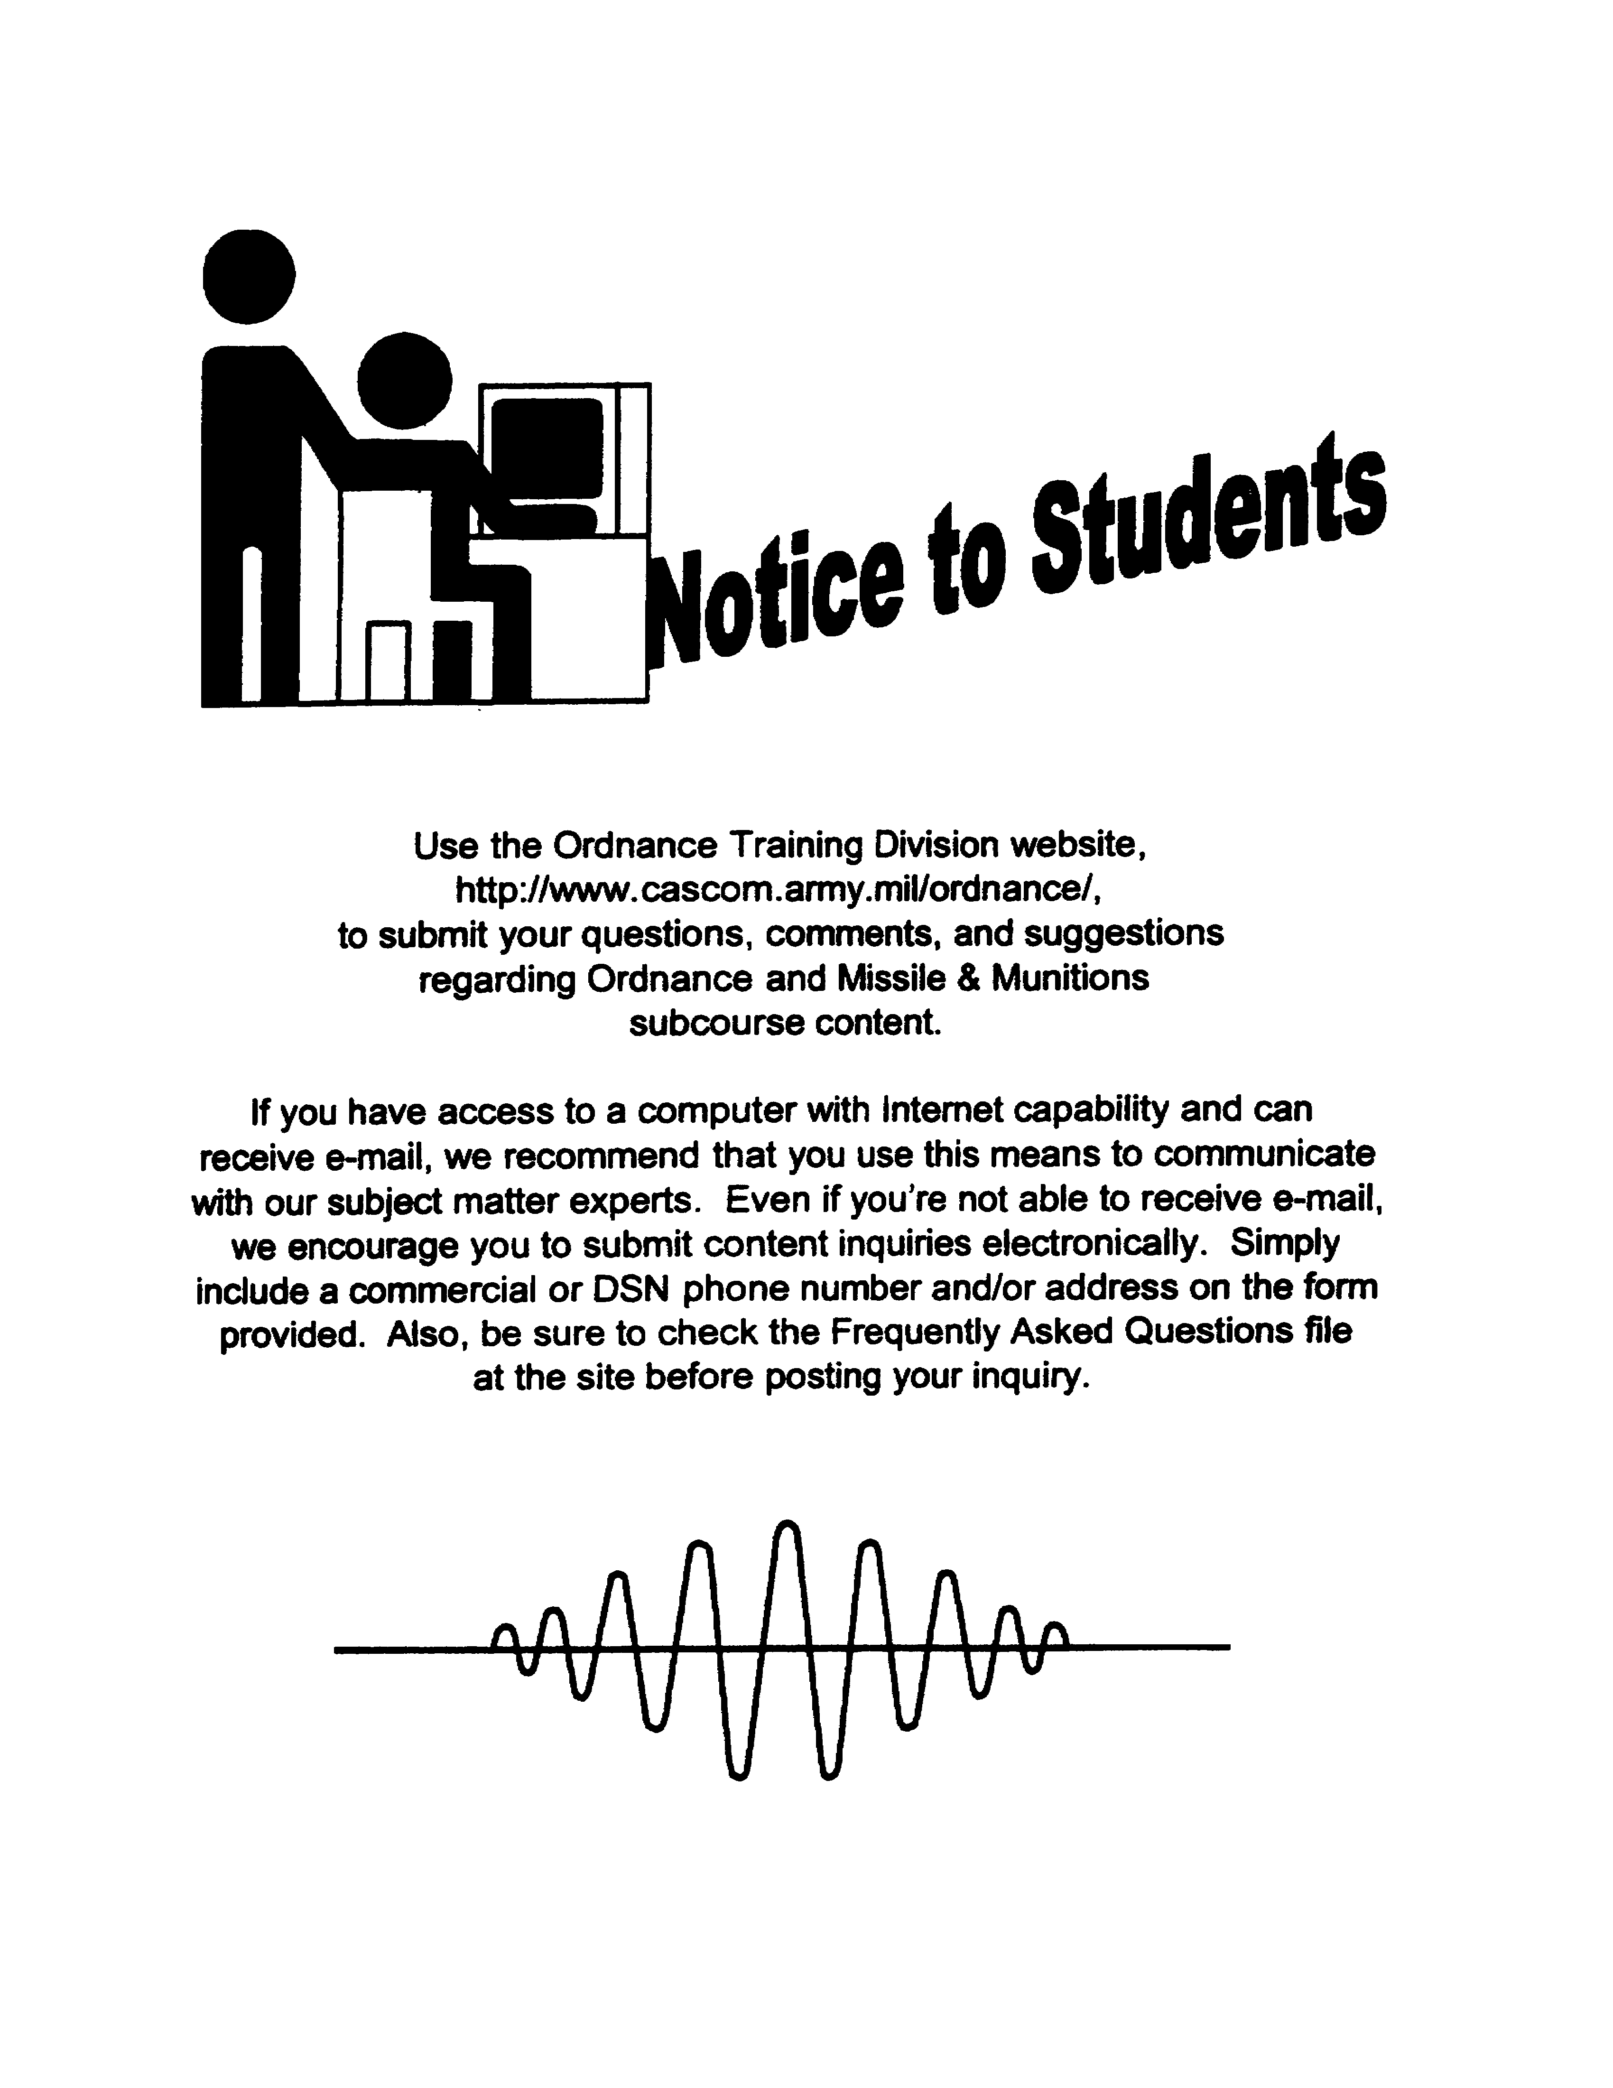

PRINCIPLES OF GUNNER'S PRIMARY SIGHT (GPS)
AND THERMAL SIGHT--M1 TANK

SUBCOURSE OD0472
Edition 7

United States Army Combined Arms Support Command
Fort Lee, VA 23801-1809

6 Credit Hours

GENERAL

The purpose of this subcourse is to introduce the gunner's primary sight (GPS) and the thermal imaging system (TIS) of the M1 tank Systems Mechanic.

This subcourse will include identification of GPS components and principles of operation for the GPS and TIS.

Six credit hours are awarded for successful completion of this subcourse.

Lesson 1: GUNNER'S PRIMARY SIGHT (GPS) AND THERMAL IMAGING SYSTEM (TIS) --M1 TANK

TASK 1: Identify the components of the GPS.

TASK 2: Describe the principles of operation for the GPS.

TASK 3: Describe the principles of operation for the TIS.

i

PRINC. OF GPS AND THERMAL SIGHT - OD 0472

TABLE OF CONTENTS

Section Page

TITLE i

TABLE OF CONTENTS ii

Lesson 1: GUNNER'S PRIMARY SIGHT (GPS) AND
THERMAL IMAGING SYSTEM (TIS) -M1
TANK 1

Task 1: Identify the components of
the GPS 1

Task 2: Describe the principles of
operation for the GPS 7

Task 3: Describe the principles of
operation for the TIS 16

Practical Exercise 1 26

Answers to Practical Exercise 1 29

REFERENCES 31

The passing score for ACCP material is 70%.

ii

PRINC. OF GPS AND THERMAL SIGHT - OD0472 - LESSON 1/TASK 1

LESSON 1

GUNNER'S PRIMARY SIGHT (GPS) AND
THERMAL IMAGING SYSTEM (TIS) --M1 TANK

TASK 1. Identify the components of the GPS.

CONDITIONS

Within a self-study environment and given the subcourse text, without assistance.

STANDARDS

Within one hour

REFERENCES

No supplementary references are needed for this task.

1. Introduction

The gunner's primary sight (GPS) is the normal sighting instrument for the main and coaxial guns on the M1 tank. An M1 Abrams tank systems mechanic must know the components of the GPS. This subcourse task will identify the components of the GPS, and the principles of their operations.

2. Components

The GPS includes the laser rangefinder (LRF) transceiver and the thermal night vision subsystem. The GPS is electrically linked in elevation to the main gun.

a. Laser Rangefinder (LRF). (See figure 1 on the following page.) The LRF is built onto the GPS. A RANGE switch, just below and to the left of the gunner's eyepiece, selects SAFE, ARM 1ST RTN, or ARM LAST RTN operating modes.

b. Ballistic Doors. The GPS is protected outside the turret by armor doors. These doors are opened and closed from inside the turret by handles

1

PRINC. OF GPS AND THERMAL SIGHT - OD0472 - LESSON 1/TASK 1

located above the GPS (see figure 2 ,on the following page).

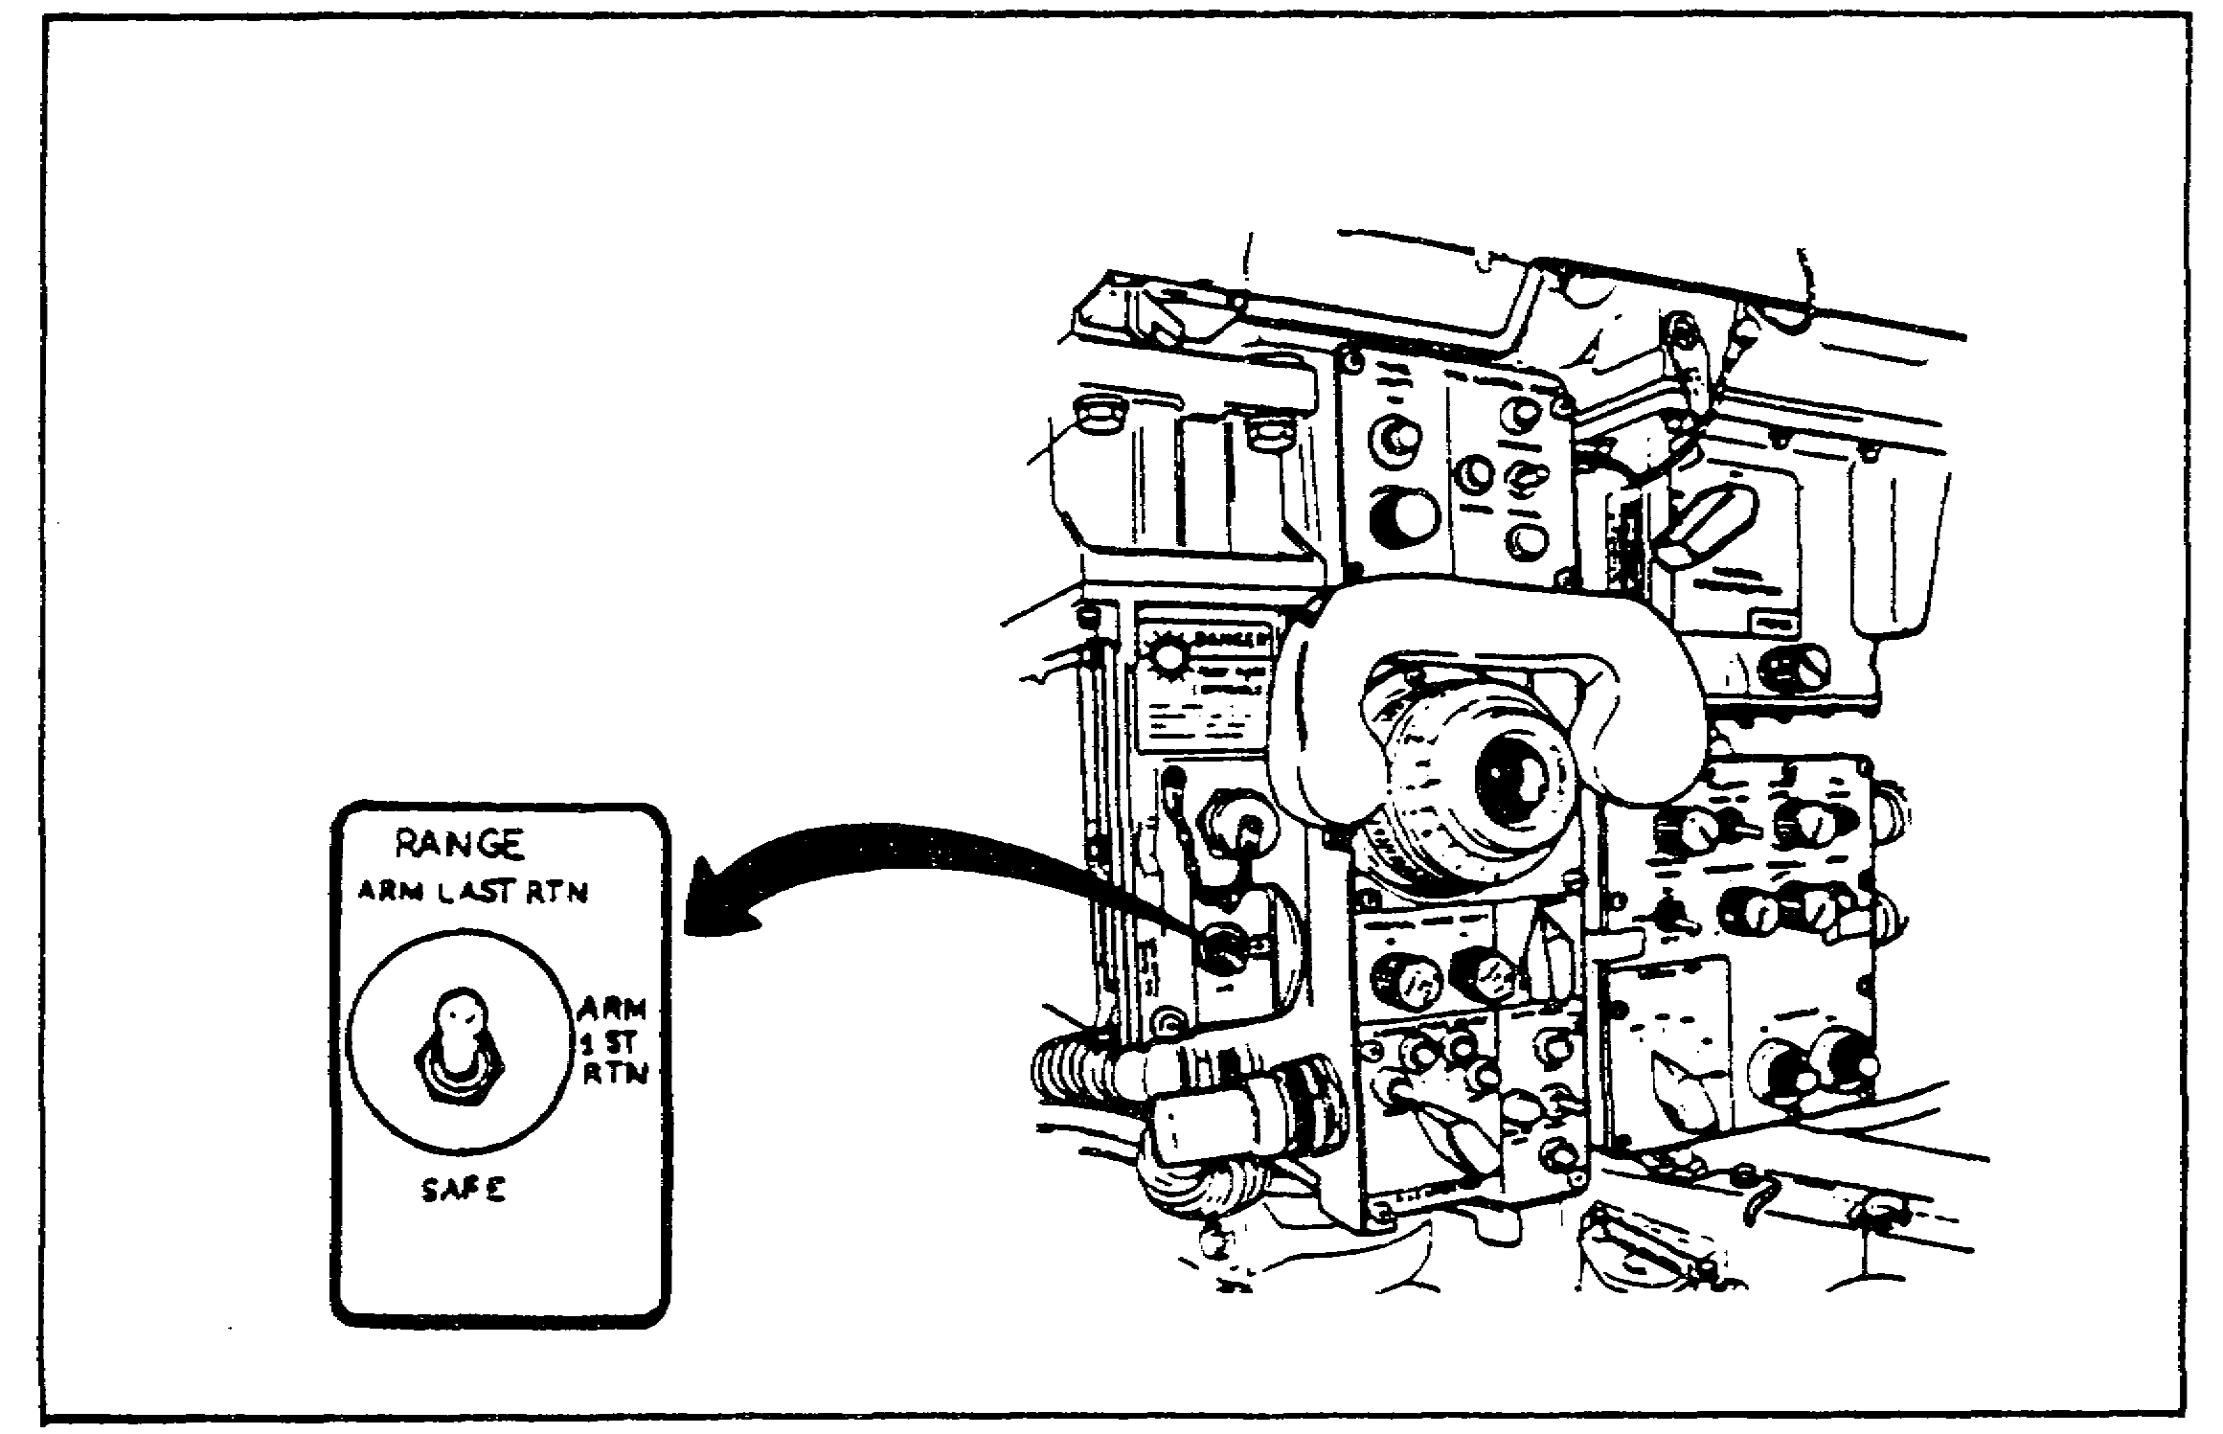

FIGURE 1. LASER RANGEFINDER RANGE SWITCH.

c. Eyepieces. (See figure 3 on the following page.) There are two eyepieces in the GPS. The eyepiece for the GPS periscope sight is at the gunner's station. An optical relay extension places a second eyepiece at the commander's station. Both gunner and commander see the same view through the sight. The eyepiece provides magnification powers of 3X and 10X through a lever.

The GPS also has an unmagnified viewer called a unity window, located above the GPS eyepiece. The unity window provides a field of view that is 6 degrees vertically and 18 degrees (30 degrees with head movement) horizontally. The unity window is used for close-in viewing.

d. Controls and Indicators. A large number of controls and indicators are tied into the GPS. These include:

(1) FIRE CONTROL MODE Switch and Lights. The switch selects, and the lights show normal, emergency, or manual fire control mode.

2
PRINC. OF GPS AND THERMAL SIGHT - OD0472 - LESSON 1/TASK 1

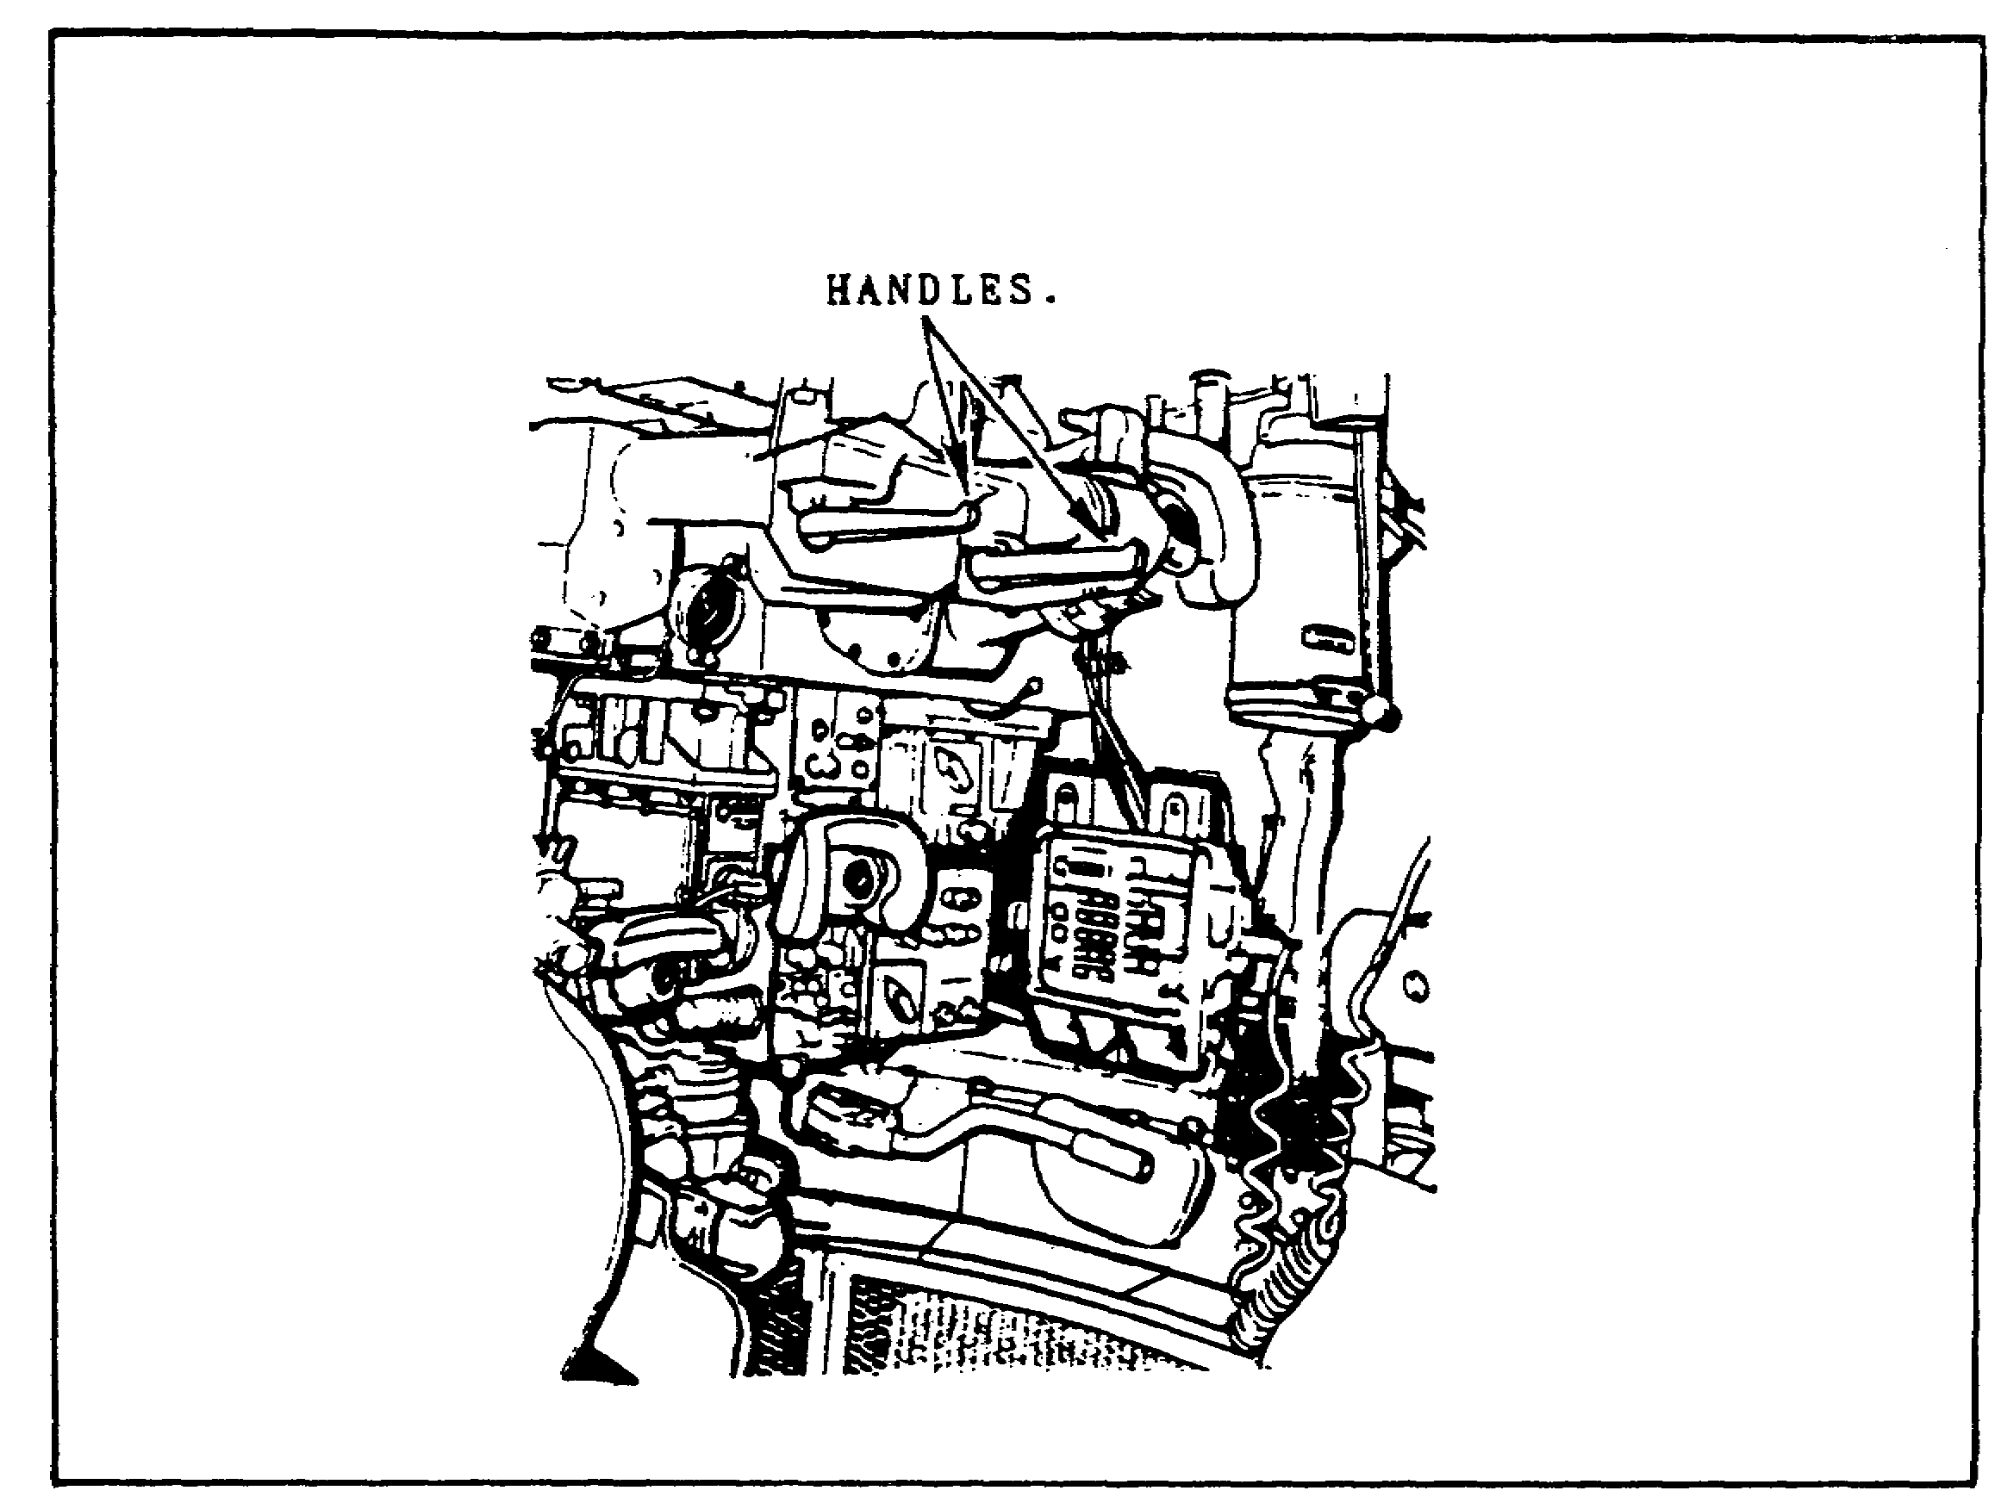

FIGURE 2. BALLISTIC DOOR HANDLES.

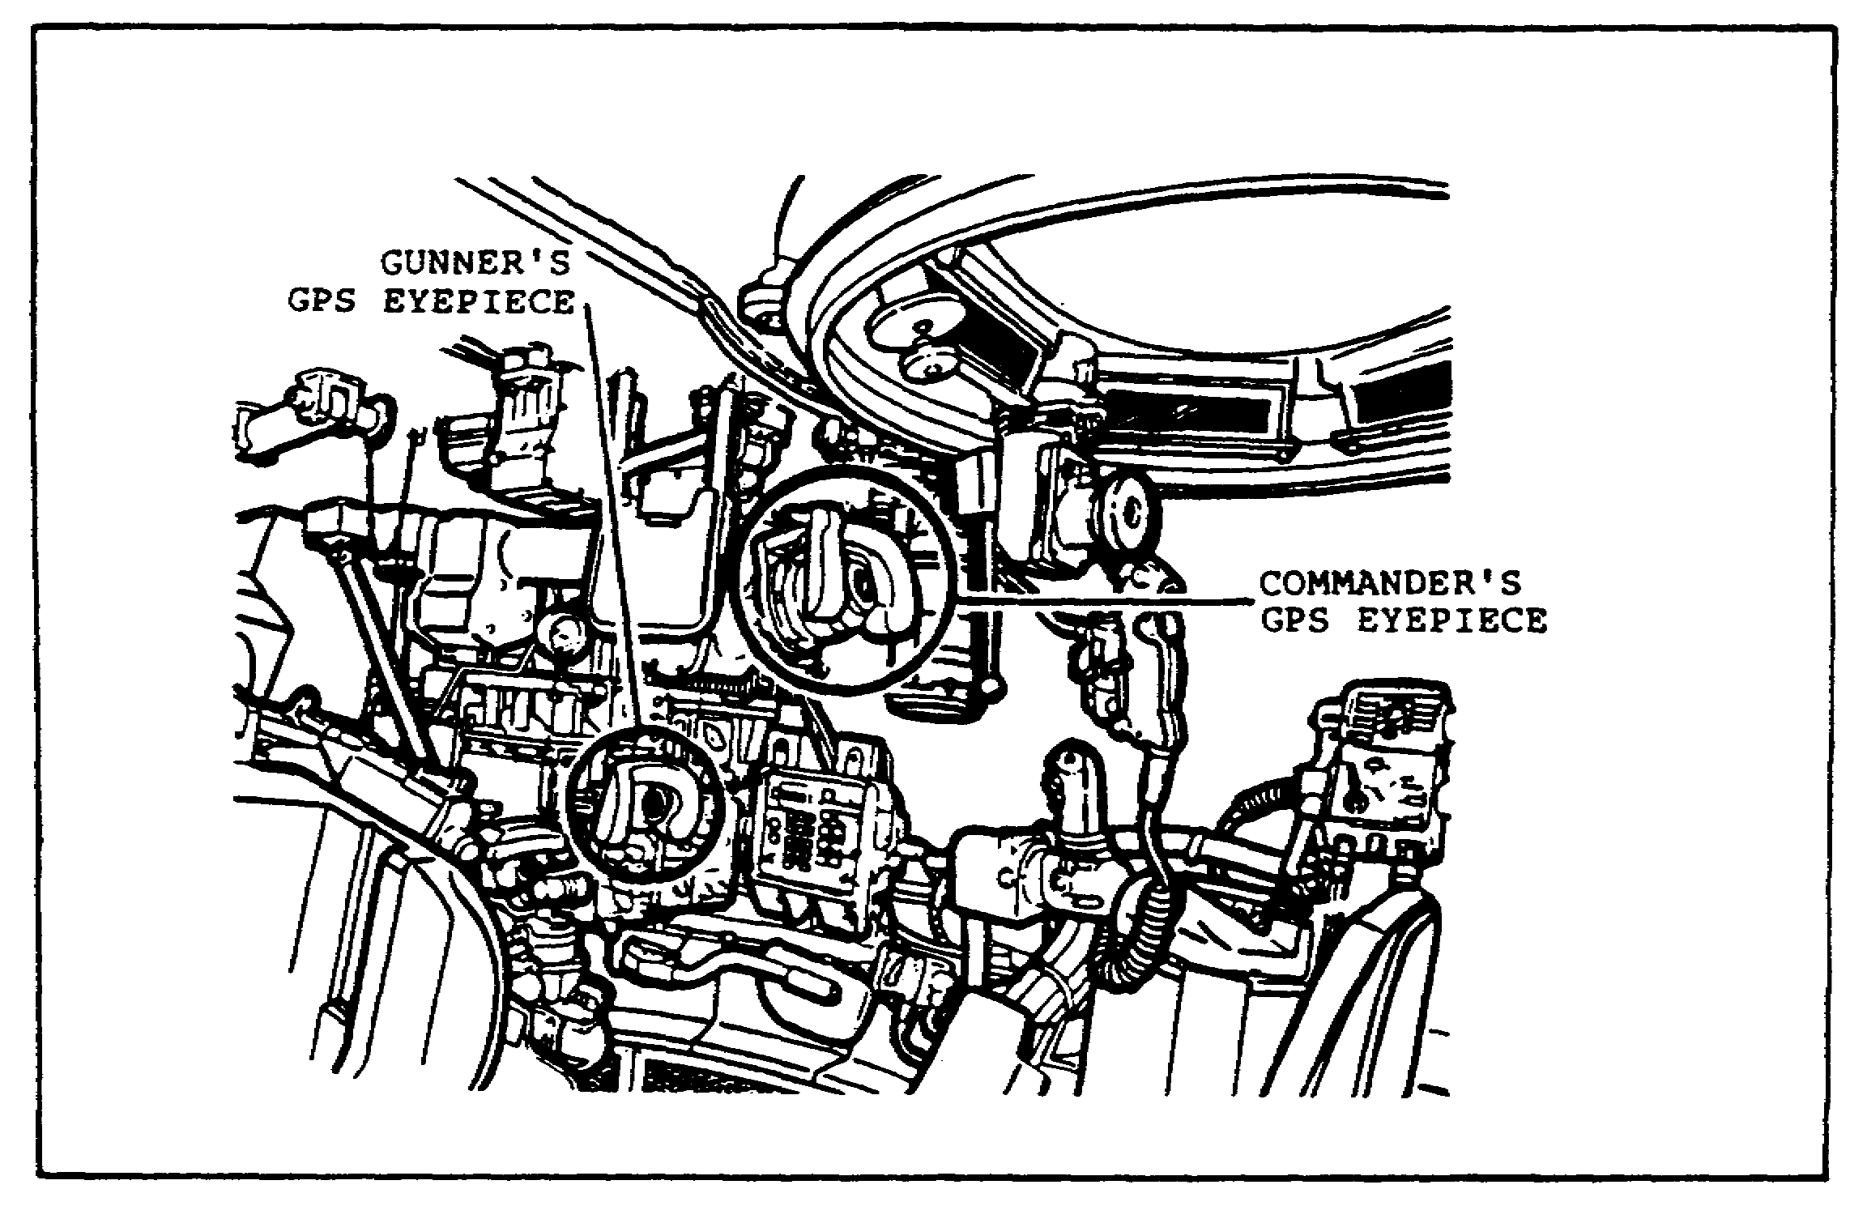

FIGURE 3. GPS EYEPIECES.
3

PRINC. OF GPS AND THERMAL SIGHT - OD0472 - LESSON 1/TASK 1

(2) FLTR/CLEAR/SHTR Switch. This control positions a filter, clear window, or shutter in the GPS day optics system.

(3) GUN SELECT Switch and Lights. The switch selects and the lights indicate main gun or coax machinegun firing circuit or trigger safe.

(4) AMMUNITION SELECT Switch and Lights. This switch gives ammunition data to the ballistic computer, when the GUN SELECT switch is set to MAIN. The lights show the type of ammunition selected. (See figure 4.)

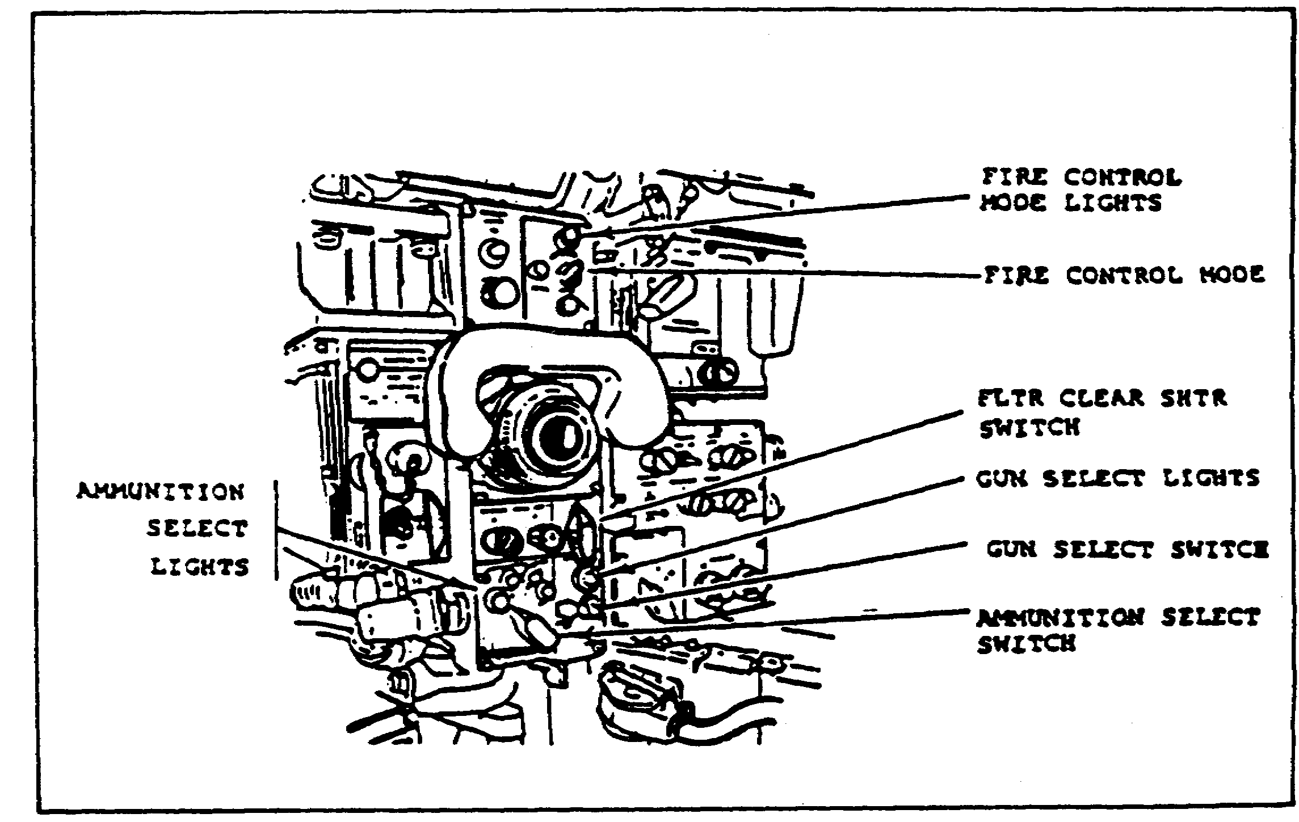

FIGURE 4. GPS CONTROLS AND INDICATORS.

(5) NORMAL MODE DRIFT Knobs. These correct for turret azimuth (AZ knob) or elevation (EL knob) drift in the stabilized (normal) sighting system.

(6) Diopter Adjustment. This lets the gunner adjust his GPS eyepiece to focus the sight reticle. The commander's GPS eyepiece also has a diopter adjustment.

(7) PANEL LIGHTS Knob and TEST Button. The knob adjusts the brightness of the GPS and thermal imaging system (TIS) indicator lights. The TEST

4

PRINC. OF GPS AND THERMAL SIGHT - OD0472 - LESSON 1/TASK 1

button brings all GPS and TIS lights to full brightness when pushed.

(8) MRS OUT/IN Lever. This lever controls a mirror that allows the muzzle reference sensor (MRS) reticle to appear in the GPS. (See figure 5.)

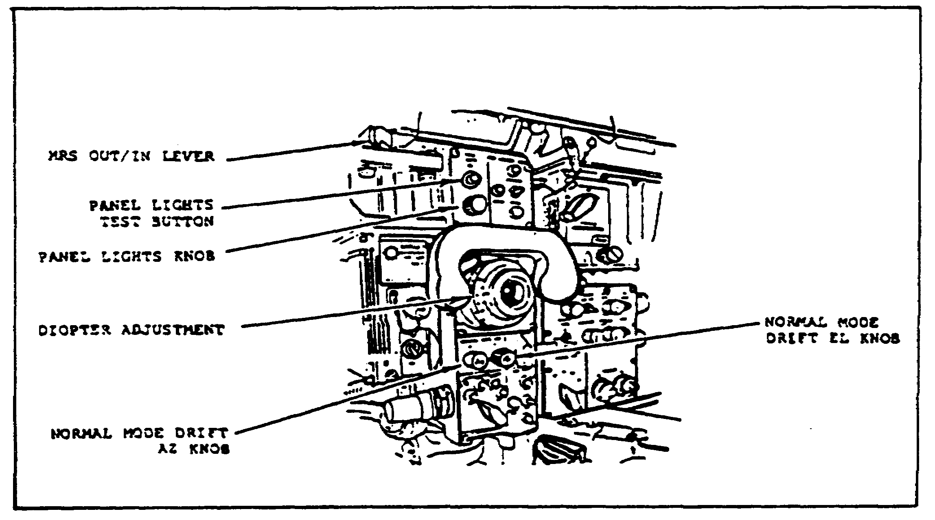

FIGURE 5. GPS CONTROLS AND INDICATORS.

(9) DEFROSTER Switch. This switch turns on the GPS defroster to provide a clear image in the GPS. The defroster operates on the daylight channel only.

(10) RETICLE Knob. This controls the GPS reticle brightness. (See figure 6 on the following page.)

The rest of the controls and indicators are used for the TIS. These will be discussed in Task 3 on page 15.

5

PRINC. OF GPS AND THERMAL SIGHT - OD0472 - LESSON 1/TASK 1

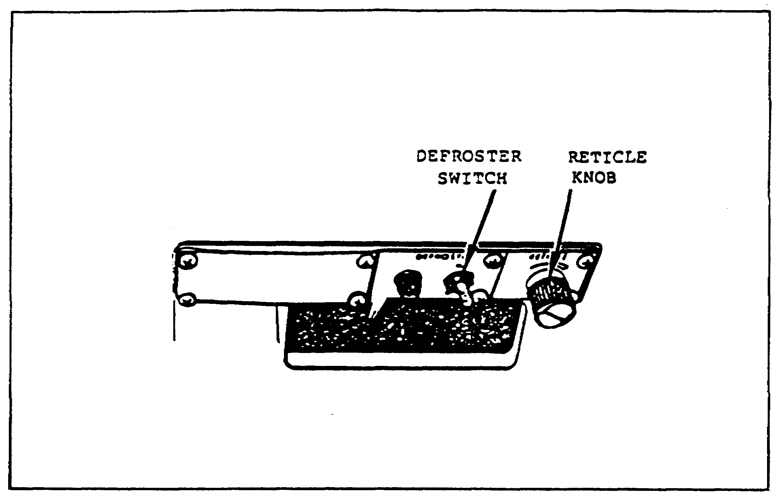

FIGURE 6. DEFROSTER AND RETICLE
BRIGHTNESS CONTROLS.

6

PRINC. OF GPS AND THERMAL SIGHT - OD0472 - LESSON 1/TASK 2

LESSON 1

GUNNER'S PRIMARY SIGHT (GPS) AND
THERMAL IMAGING SYSTEM (TIS) --M1 TANK

TASK 2. Describe the principles of operation for the GPS.

CONDITIONS

Within a self-study environment and given the subcourse text, without assistance.

STANDARDS

Within two hours

REFERENCES

No supplementary references are needed for this task.

1. Introduction

Task 1 introduced the components of the gunner's primary sight (GPS) of the M1 tank. Here we will discuss the operating principles of the GPS--how the components come together to allow the gunner to see what the main gun is firing upon.

2. GPS Principles of Operation

The GPS offers a range of daylight vision choices. (Nighttime vision is provided by the thermal imaging system [TIS], which will be discussed in Task 3 on page 15.) The GPS offers unmagnified, or unity, vision through the unity window above the GPS, or 3X or 10X vision selected by the magnification lever and fed to the GPS eyepiece.

The fire control system displays three symbols in the GPS eyepiece. The ready-to-fire, multiple return, and malfunction F symbols (see figure 7 on the following page) are generated in the TIS, by the electronics unit (EU).

7

PRINC. OF GPS AND THERMAL SIGHT - OD0472 - LESSON 1/TASK 2

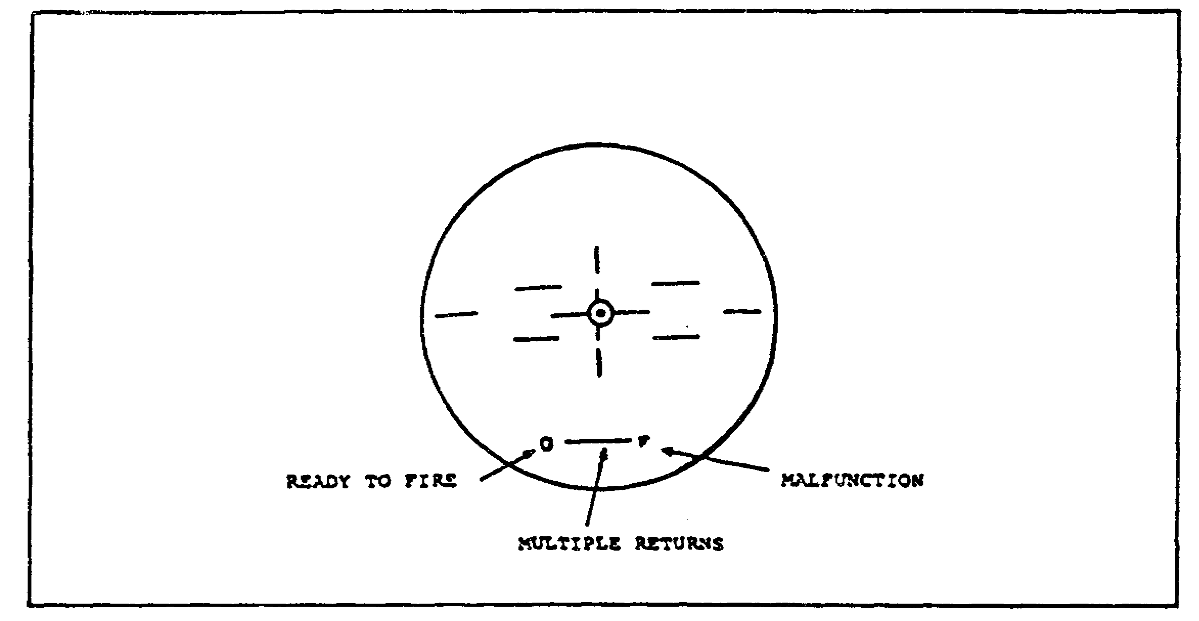

FIGURE 7. GPS EYEPIECE SYMBOLS.

The lines in the reticle are called stadia lines. The lines running up and down are for range. The lines running across are used to determine target lead in the emergency mode.

a. Ready-to-Fire Symbol. The ready-to-fire symbol is a square in the lower left of the view. The symbol appears when all of the following conditions are met:

o A ballistic solution has been calculated by the computer

o The GPS reticle is in the position required by the ballistic solution

o The spent case ejection guard (also called the brass catcher) is in the armed (rear) position

o The gunner's or commander's control handle palm switch is depressed

The ready-to-fire symbol does not indicate that the correct ammunition type has been selected, or that the range display shows correct range. These decisions must be made by the commander or the gunner.

b. Multiple Return Symbol. The multiple return symbol is a bar that appears above the range display. The symbol appears when the LRF receives more than one return. The range value displayed

8

PRINC. OF GPS AND THERMAL SIGHT - OD0472 - LESSON 1/TASK 2

will be either the first or last return, depending upon the position of the laser RANGE switch.

When the multiple return symbol appears, the operator (either the commander or the gunner) must decide whether the displayed range appears valid. If it is not valid, the LRF should be fired at the target again. If the range value is flashing when the multiple return symbol appears, the operator should lase again.

NOTE

When it is necessary to relase on a target, the old range data must be cleared from the computer before relasing.

c. Malfunction Symbol. The malfunction symbol indicates that one or more of the following fire control system malfunctions exist:

o Computer is self-testing

o The last computer manual test failed

o No laser rangefinder power

o LRF failure

o Laser RANGE switch not in SAFE position when turret power was turned on

o No thermal imaging system power

o Cant unit failure

o Line-of-sight (LOS) electronics failure

o Gun/turret drive (GTD) system failure

o Crosswind sensor failure

o One or more critical turret cables disconnected

d. LRF Operation.

9

PRINC. OF GPS AND THERMAL SIGHT - OD0472 - LESSON 1/TASK 2

WARNING

The LRF is a potentially dangerous instrument. It should be regarded as a DIRECT FIRE WEAPON with a hazardous range of 8000 meters.

There are many warnings regarding use of the LRF. These warnings appear frequently throughout the technical manuals that apply to the M1 tank. If you wish or have need to read these warnings, consult any TM in the 9-2350-255-series.

The LRF can range on targets located from 200 to 7990 meters from the tank, with an accuracy of plus or minus 10 meters. The LRF finds range to a target by sending out a pulse of light and measuring the time until the pulse returns to the receiver.

If the range to the target is between 200 and 4000 meters, the range is automatically placed in the ballistic computer. The range appears in the range display of the GPS. If the target is between 4010 and 7990 meters, the range appears in the GPS as a flashing number. This tells the gunner and the tank commander that the range is not automatically entered into the ballistic computer and that it must be entered manually. (See figure 8.)

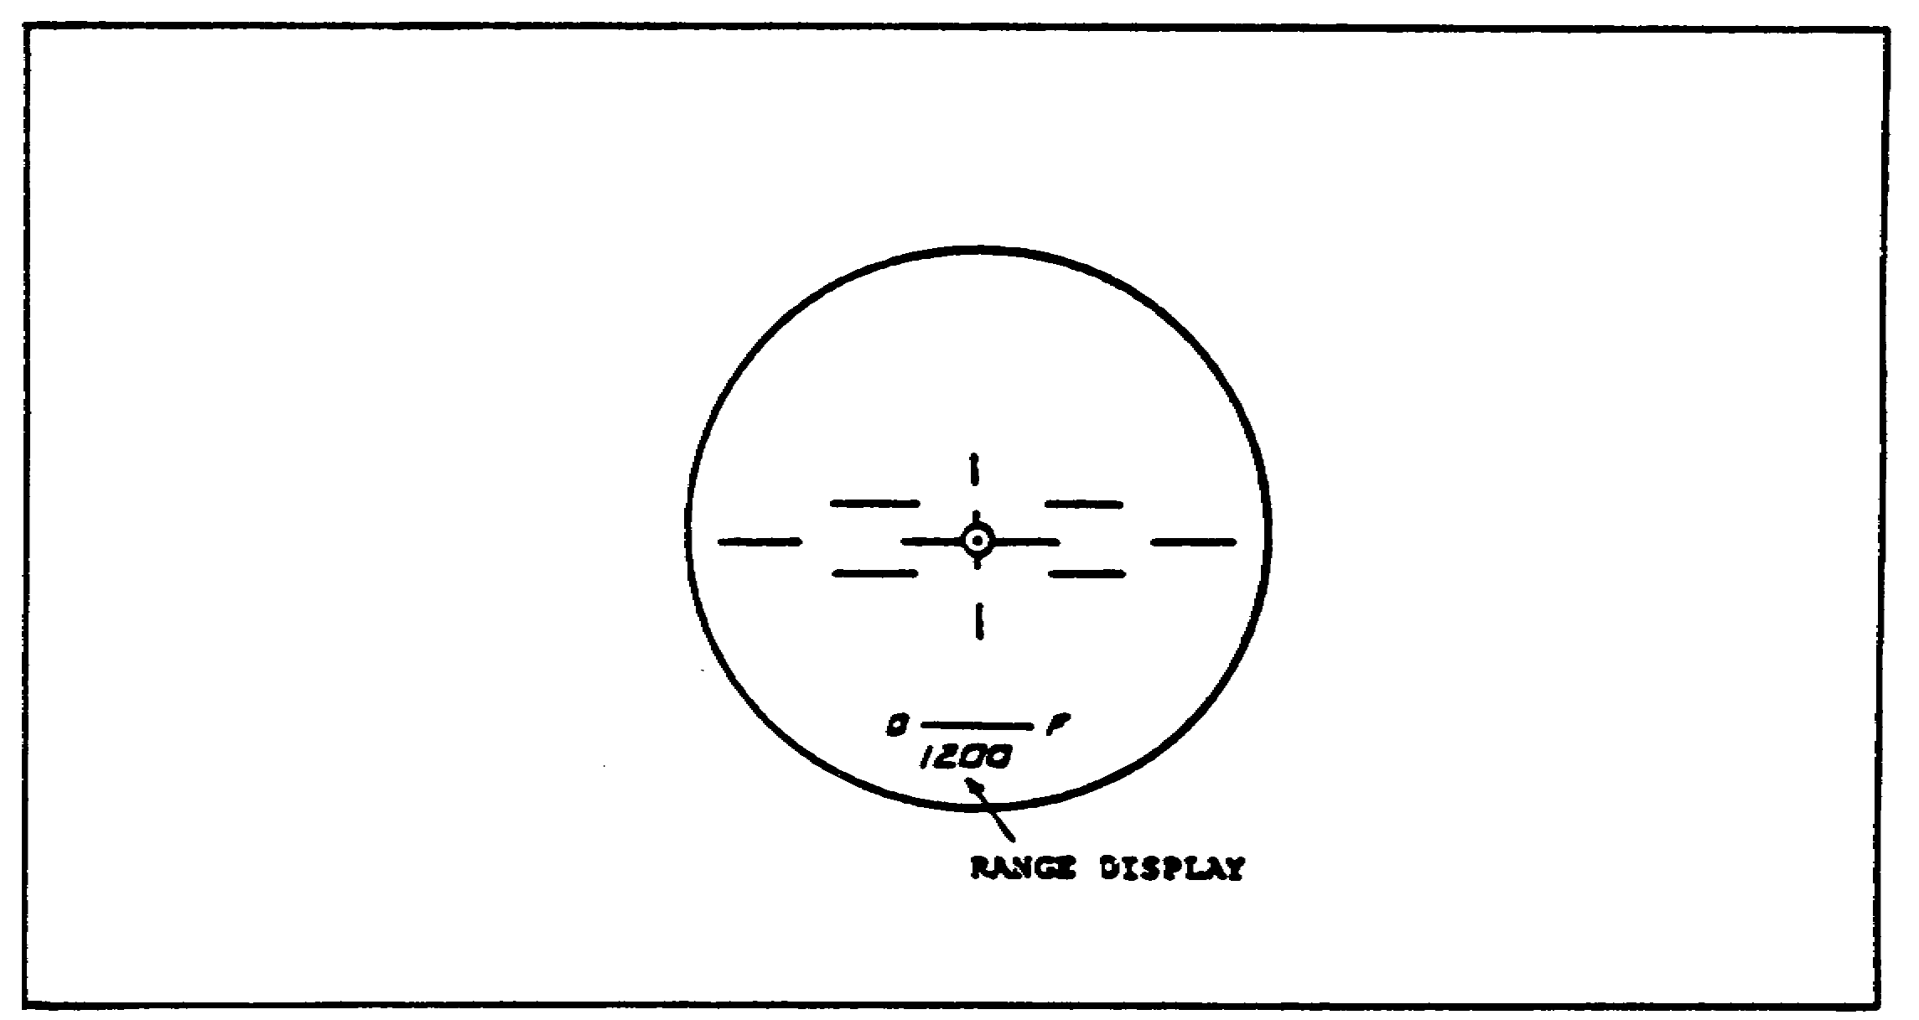

FIGURE 8. LRF RANGE DISPLAY IN GPS.

10

PRINC. OF GPS AND THERMAL SIGHT - OD0472 - LESSON 1/TASK 2

There are three occasions when the range display will show a flashing "0000" in the GPS:

o When all returns are less than 200 meters away

o When insufficient light is returned to the receiver to calculate the range

o When the target is farther than 8000 meters from the tank

Multiple returns will be received whenever the laser beam strikes more than one object. When this happens, the multiple return bar appears above the range display in the GPS. The range displayed will be either the first return or the last return, depending upon the setting of the RANGE switch. Dense fog, dust clouds, or smoke between the LRF and the target can cause false returns. Crewmembers should use range estimation or battlesight procedures when there are conditions that might result in false returns.

The GPS day reticle pattern seen in the eyepiece is generated in the LRF. The LRF uses the GPS day optics at all times, even when the LRF is used at night with the thermal imaging system (TIS) optics. Therefore, the day ballistic door of the GPS must remain open for day or night operations whenever the LRF is being used. The TIS reticle must be boresighted to the day reticle at all times or the LRF will not align with the TIS reticle.

Most combat situations call for the use of the ARM LAST RTN position of the RANGE switch. ARM LAST RTN provides the correct range to the target if the laser beam in the field of view is stopped by the target. Usually, the target is larger than the laser beam. Therefore, the laser beam will be reflected from the target and the last return will be the correct range, regardless of the number of multiple returns. The last return will be correct over 90 percent of the time in a combat environment.

The ARM 1ST RTN setting should be used when there are no obstacles between the tank and the intended target. ARM 1ST RTN is also useful for training targets such as panels or cloth silhouettes. These targets can develop holes which allow the laser beam to pass through and produce multiple returns.

11

PRINC. OF GPS AND THERMAL SIGHT - OD0472 - LESSON 1/TASK 2

ARM 1ST RTN can also be used for targets that are situated above ground level. The laser can pass underneath such a target and produce multiple returns.

e. Operating the GPS. After powering up the gunner's station and performing a functional check on the GPS, the GPS is ready for operation. The steps in actually using the GPS are presented here.

(1) Open the day ballistic door (see figure 2 on page 3). This door must be open for both daytime vision and LRF operation. If frost or fog is affecting the view through the GPS eyepiece, turn on the defroster. The defroster only works for the daylight channel.

(2) Turn the RETICLE knob clockwise to make the reticle image brighter, or counterclockwise to make the image dimmer. The image should be just bright enough to be barely visible in the eyepiece. The image should be as dim as possible to keep it from interfering with seeing and identifying targets.

(3) Press and hold the PANEL LIGHTS TEST button periodically during operation, to make sure all GPS and TIS lights are working. Use the PANEL LIGHTS knob to set the brightness of the lights during normal operation. Clockwise turning brightens the panel lights; counterclockwise turning dims them.

(4) Set the MRS lever to IN momentarily to check the muzzle reference sensor (MRS) adjustment. For most operation of the GPS, the MRS lever will be set to OUT.

(5) Turn the diopter adjustment, the grooved ring in the eyepiece housing, as necessary, to focus the reticle in the GPS eyepiece. This adjustment will be different for different operators, so each operator should remember the reference pointer setting for future use. (See figure 9 on the following page.)

(6) Set the FIRE CONTROL MODE switch to whichever setting is desired.

(a) NORMAL mode provides stabilized power control of the main gun and coaxial machinegun for engaging targets while the tank is either moving or stationary. NORMAL mode will work 30 seconds after the turret power is turned on. The GUN/TURRET

12

PRINC. OF GPS AND THERMAL SIGHT - OD0472 - LESSON 1/TASK 2

DRIVE switch on the loader's panel must be in either the POWERED or EL UNCPL position for NORMAL mode to work. Make sure that the hydraulic pressure is between 1500 and 1700 pounds per square inch (psi). Below 1500 psi, operation in NORMAL mode may become erratic.

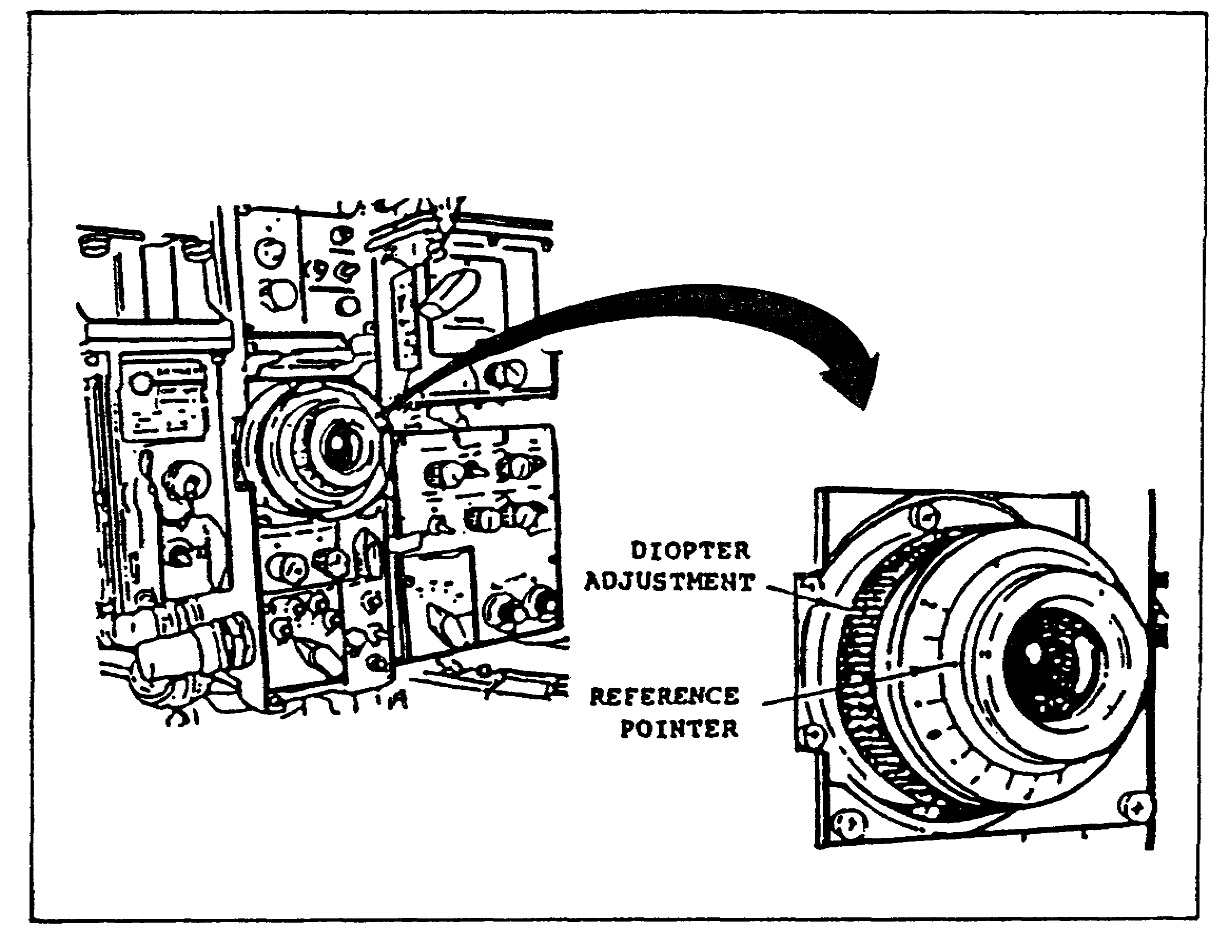

FIGURE 9. RETICLE FOCUS ADJUSTMENT.

(b) EMERGENCY provides unstabilized power control of the main gun and coaxial machinegun, for engaging targets from a stationary position. Reticle motion will increase in the GPS eyepiece if the tank is in motion.

(c) MANUAL disables all power controls. Both the gun and the turret can be moved only by hand, using manual turret and elevation crank handles.

(7) Use the NORMAL MODE DRIFT knobs to null out reticle drift in the GPS eyepiece.

(8) Turn the FLTR/CLEAR/SHTR switch to the desired position.

13

PRINC. OF GPS AND THERMAL SIGHT - OD0472 - LESSON 1/TASK 2

(a) FLTR position filters out bright light by placing a neutral density filter in the eyepiece.

(b) CLEAR position is used for normal day viewing; nothing is placed in the line of sight.

(c) SHTR position is used only with the thermal imaging system (TIS). The clear view is blocked by a shutter and the TIS channel appears in the GPS eyepiece.

(9) Set the GUN SELECT switch to the desired position. The GUN SELECT switch selects the main gun or the coaxial machinegun circuit for firing. When the switch is in the center position, TRIGGER SAFE, neither gun can be fired electrically. The GUN SELECT switch automatically goes to TRIGGER SAFE when turret power is turned off. Unless targets are being engaged, the GUN SELECT switch should always be in TRIGGER SAFE.

(10) Move the MAGNIFICATION lever to the 3X or 10X position as desired. The MAGNIFICATION lever is located beneath the AMMUNITION SELECT switch on the GPS.

(11) If targets will be engaged and the GUN SELECT switch is set to MAIN, set the AMMUNITION SELECT switch to the type of ammunition that is to be used.

Those are the operating principles and procedures of the M1 tank gunner's primary sight (GPS). In the task that follows, the principles and procedures for the thermal imaging system (TIS), the unit that gives the gunner nighttime vision to aim the guns, will be introduced.

14

PRINC. OF GPS AND THERMAL SIGHT - OD0472 - LESSON 1/TASK 3

LESSON 1

GUNNER'S PRIMARY SIGHT (GPS) AND
THERMAL IMAGING SYSTEM (TIS) --M1 TANK

TASK 3. Describe the principles of operation for the TIS.

CONDITIONS

Within a self-study environment and given the subcourse text, without assistance.

STANDARDS

Within two hours

REFERENCES

No supplementary references are needed for this task.

1. Introduction

The prior tasks in this subcourse introduced the components and principles of operation of the gunner's primary sight (GPS) on the M1 tank. The GPS provides magnified daytime vision for aiming both the main gun and the coaxial machinegun on the M1. It includes some fire control devices such as the GUN SELECT and AMMUNITION SELECT switches. However, the GPS does not provide any nighttime vision capability. That task is handled by the thermal imaging system (TIS), which feeds its image into the GPS for nighttime operations and engaging of targets. The TIS looks for warm objects in its field of view and converts the heat inputs into a video picture for the GPS.

This task introduces the TIS. In addition to presenting the controls for the TIS, the operation of the TIS and how the controls are used to produce and refine the image which is seen in the GPS will be presented.

15

PRINC. OF GPS AND THERMAL SIGHT - OD0472 - LESSON 1/TASK 3

2. TIS Controls

The TIS controls are located just to the right of the GPS eyepiece. (See figure 10.) These controls include:

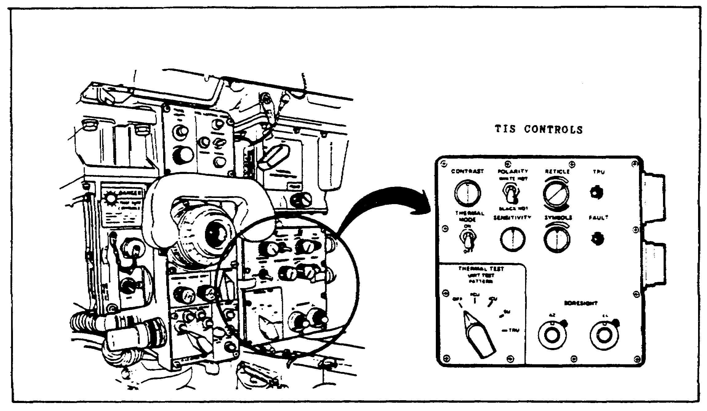

FIGURE 10. LOCATION OF TIS CONTROLS.

a. CONTRAST Knob. This controls the contrast of the TIS image.

b. POLARITY Switch. This selects a white or black presentation of hot objects in the TIS image.

c. RETICLE Knob. Turning this knob whitens or blackens the reticle image in the TIS.

d. TRU READY Light. This lights green when the thermal receiver unit (TRU) is ready for operation. (See figure 11 on the following page.)

e. SYMBOLS Knob. This knob controls the brightness of the range, multiple returns, ready-to-fire, and malfunction F symbols in the GPS field of view. The SYMBOLS knob functions for both TIS and daytime operation.

f. FAULT Light. This light indicates a variety of malfunctions in the TIS when turret power is applied to the TIS.

16

PRINC. OF GPS AND THERMAL SIGHT - OD0472 - LESSON 1/TASK 3

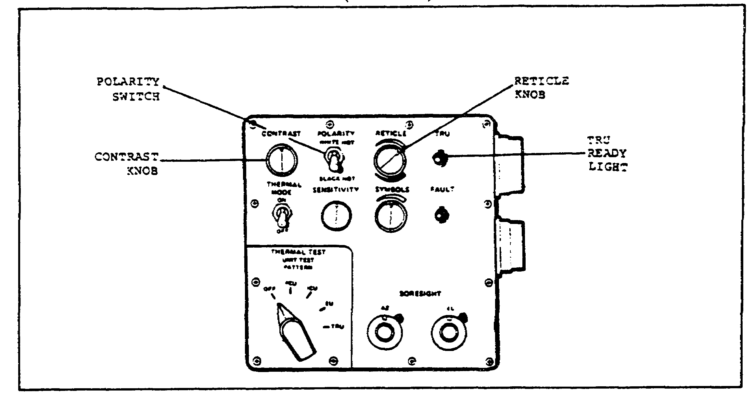

FIGURE 11. TIS CONTROLS (1 OF 2).

g. BORESIGHT Knobs and Lock Levers. The BORESIGHT knobs set the TIS reticle in elevation (EL) and azimuth (AZ) when aligning the TIS reticle with the GPS reticle during boresighting. The lock levers hold the boresight knobs in position once the reticles have been properly aligned.

h. UNIT TEST PATTERN Switch. This switch selects a thermal test for each TIS unit.

i. SENSITIVITY Knob. The SENSITIVITY knob controls the brightness of the TIS image.

j. THERMAL MODE Switch. The THERMAL MODE switch places the TIS in ON, OFF, or standby (STBY) modes. (See figure 12 on the following page.)

k. THERMAL MAGNIFICATION and FOCUS Controls. These controls are located above the main TIS control panel on the right of the GPS eyepiece. The THERMAL MAGNIFICATION switch selects 3X or 10X magnification of the thermal image. The FOCUS control allows the TIS reticle to be focused in the GPS eyepiece.

3. TIS Principles of Operation

The TIS provides the M1 fire control system with night vision capability by presenting a thermal scene in the GPS eyepiece. The TIS picture can be viewed at 3X or 10X magnification.

17

PRINC. OF GPS AND THERMAL SIGHT - OD0472 - LESSON 1/TASK 3

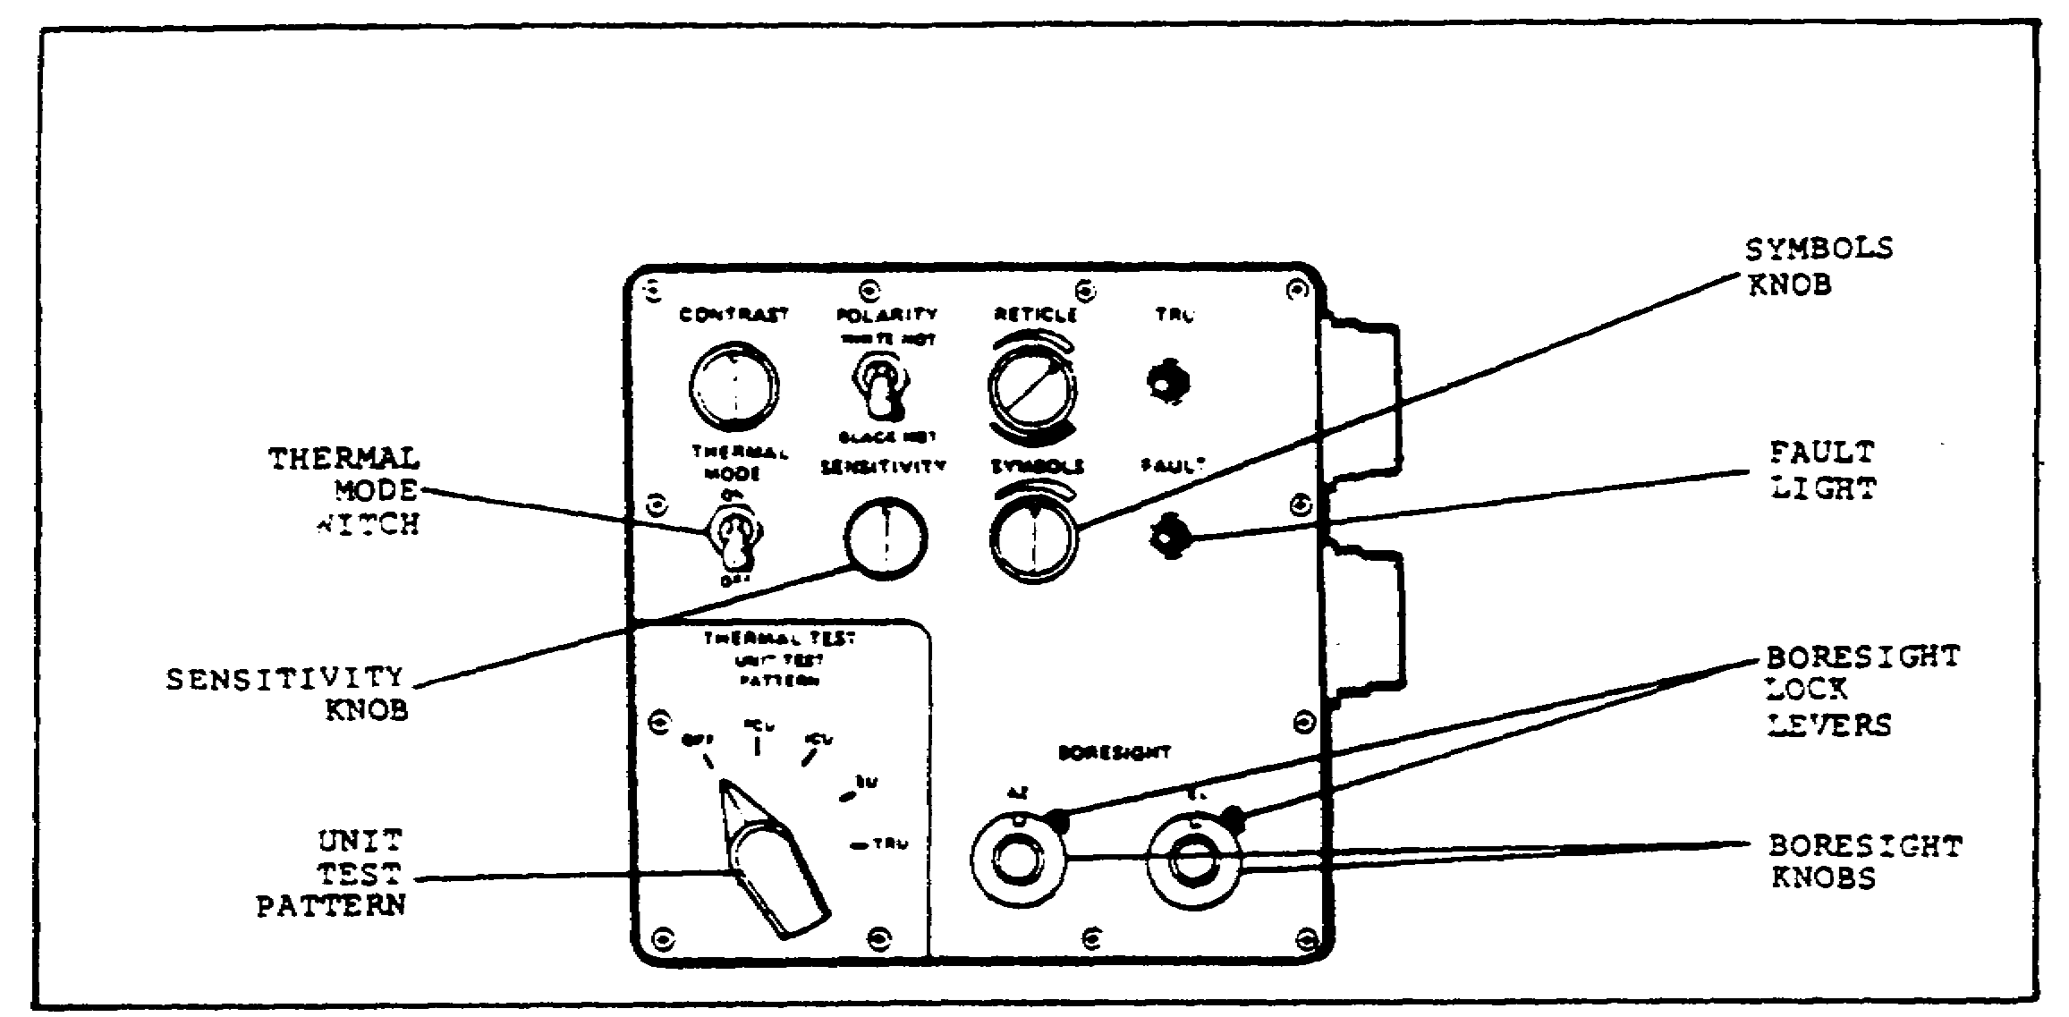

FIGURE 12. TIS CONTROLS (2 OF 2).

The TIS electronics unit (EU) generates the range and symbol data for the GPS. The EU and power control unit (PCU) are on whenever turret power is on. The range, ready-to-fire, and malfunction symbols are generated whenever turret power is on.

Target scene information is detected by heat sensors in the TIS thermal receiver unit (TRU); therefore, the TIS must be cooled down before use, unless the combat situation demands immediate engagement of targets. This scene information is converted to electrical signals, processed by the EU, and sent to the image control unit (ICU) for display on a cathode ray tube (CRT). The CRT image is then optically projected into the GPS eyepiece for viewing by the gunner and commander. The POLARITY switch selects light hot images on a dark background, or dark hot images on a light background.

The TIS uses range information from the laser rangefinder (LRF), which operates through the day channel sight. Therefore, both the day and night ballistic doors must be open during operation of the TIS. With the day channel ballistic door open, the daylight view will appear in the GPS eyepiece unless the FLTR/CLEAR/SHTR switch is kept in the SHTR position during TIS operation. The shutter also turns off the day reticle illumination which can be seen when looking into the sight window from outside the tank.

18

PRINC. OF GPS AND THERMAL SIGHT - OD0472 - LESSON 1/TASK 3

The TIS uses the same range information that the day channel does. Because of this, the TIS reticle must be aligned and boresighted to the main gun's point of aim every time the day reticle is boresighted or checked. It is very critical to ensure that the daylight and TIS reticles are not aligned by superimposing one upon the other. The correct procedure is to refer each reticle to the same aim point on a distant target.

It is important that the TIS picture is correctly adjusted. Target acquisition and identification can be seriously degraded with an incorrectly adjusted TIS picture. Misuse of some controls on the image control unit can even make the TIS picture disappear.

4. Operating the TIS

a. TIS Checkout. After turning on turret power and powering up the gunner's station, make sure the THERMAL MODE switch is set to STBY (standby); the TIS is then ready for checkout. When operating the TIS without the engine running, check the LOW BAT CHG (low battery charge) light on the commander's control panel every 10 to 15 minutes. If the light comes on, something is not operating properly and troubleshooting procedures must be performed.

(1) Set the FLTR/CLEAR/SHTR switch to SHTR and the POLARITY switch to WHITE HOT.

(2) Set the THERMAL MAGNIFICATION lever to 3X. Make sure the lever snaps into position.

(3) Set the UNIT TEST PATTERN switch to PCU and look at the FAULT light. If it stays on for more than five seconds, notify unit maintenance. Any time the UNIT TEST PATTERN switch is moved, the FAULT light may come on. It should go out within five seconds. If the correct test pattern does not appear for any switch setting, as shown in figures 13 through 16, then unit maintenance would have to troubleshoot according to TM 9-2350-255-20-2-2-2.

(4) Look into the GPS eyepiece. The view should contain no test pattern image. The range data already in the ballistic computer should appear at the bottom of the view. A rectangle box, called the TIS raster, may be faintly visible and the fire

19

PRINC. OF GPS AND THERMAL SIGHT - OD0472 - LESSON 1/TASK 3

control fault F symbol may appear. An F in the view can be ignored for now. (See figure 13.)



FIGURE 13. PCU TEST PATTERN.

(5) Set the UNIT TEST PATTERN switch to ICU and look at the FAULT light; it should go out within five seconds. Look into the GPS eyepiece. The view should have a test pattern with a darkened upper right quarter of the picture. The TIS raster may be faintly visible. No symbols should be visible at the bottom of the view. (See figure 14.)



FIGURE 14. ICU TEST PATTERN.

(6) Set the UNIT TEST PATTERN switch to EU and the THERMAL MODE switch to ON. As before, check that the FAULT light goes out within five seconds. Look into the eyepiece. The view should have corner symbols and all symbols should be visible at the bottom of the view. The range indicator will

20

PRINC. OF GPS AND THERMAL SIGHT - OD0472 - LESSON 1/TASK 3

show "8" in all four positions. The TIS raster may be faintly visible. (See figure 15.)

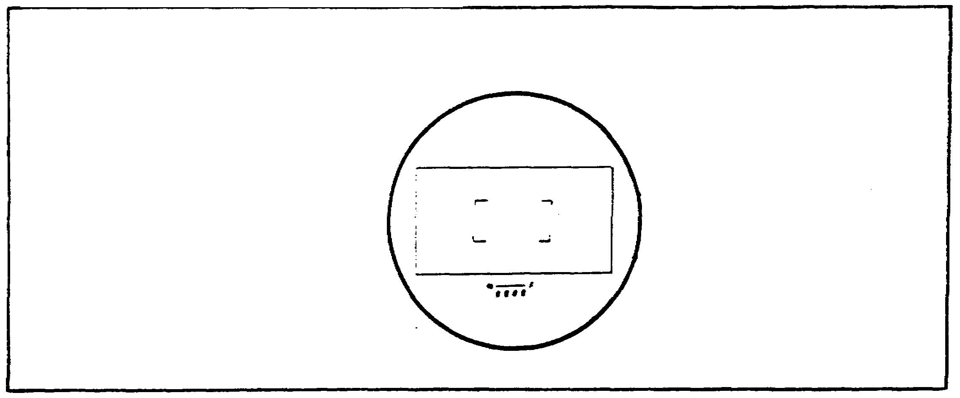

FIGURE 15. EU TEST PATTERN.

(7) Set the THERMAL MAGNIFICATION lever to 10X and look into the GPS eyepiece. The view should show the TIS reticle moving around. The range indicator will show "8" in all positions.

(8) Look at the TRU READY light. It should come on within five to 15 minutes after the THERMAL MODE switch is set to STBY. If the TRU READY light does not come on within 15 minutes, notify unit maintenance.

(9) Set the UNIT TEST PATTERN switch to TRU and check the FAULT light. It should go out within five seconds. Look into the GPS eyepiece. The view should have the reticle in the center area with a vertical bar left of the reticle. The range data currently in the computer will appear at the bottom. The TIS raster may be faintly visible, and the F fire control malfunction symbol may appear. Ignore any F that appears now. (See figure 16 on the following page.)

(10) Turn the CONTRAST knob clockwise and counterclockwise. The bar (see figure 16) should brighten and dim respectively as the knob is turned. Turn the SENSITIVITY knob clockwise and counterclockwise. The entire display pattern should brighten and dim respectively as the knob is turned. Turn the RETICLE knob clockwise and counterclockwise. The reticle itself should get whiter or blacker, respectively, as the knob is

21

PRINC. OF GPS AND THERMAL SIGHT - OD0472 - LESSON 1/TASK 3

turned. If any of these knobs do not give the proper results, contact unit maintenance.

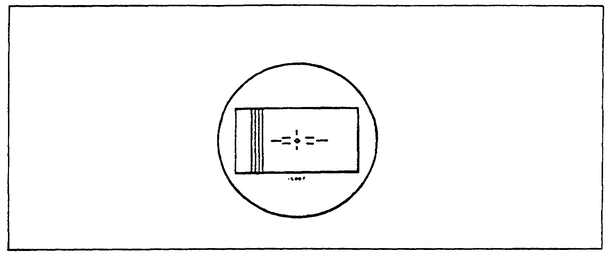

FIGURE 16. TRU TEST PATTERN.

(11) Set the POLARITY switch to BLACK HOT. The display pattern should change to a dark bar on a light green background. Reset the POLARITY switch to WHITE HOT. The pattern should show a light bar on a dark background. If these changes do not occur, notify unit maintenance. (See figure 17.)

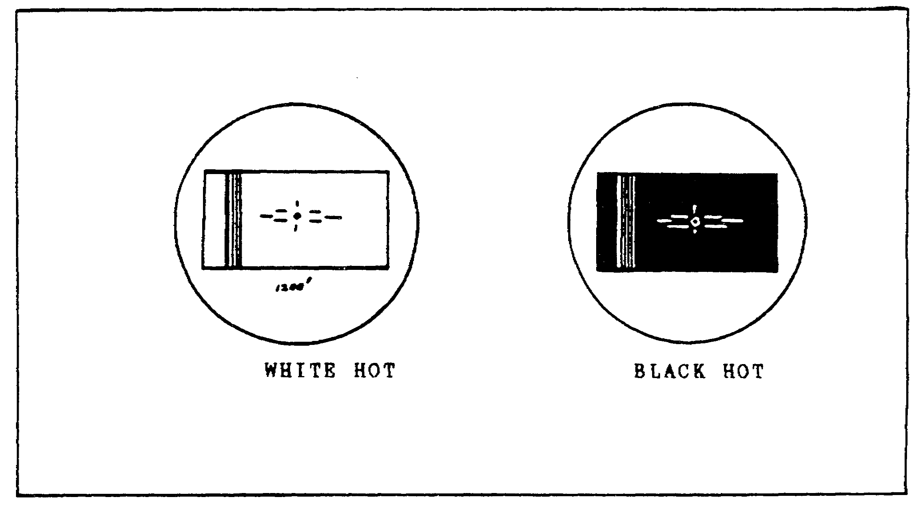

FIGURE 17. POLARITY DISPLAYS.

(12) Set the UNIT TEST PATTERN switch to OFF and make sure the thermal ballistic door is open. Look into the GPS eyepiece and, using manual or power

22

PRINC. OF GPS AND THERMAL SIGHT - OD0472 - LESSON 1/TASK 3

controls, lay the main gun on a target at least 1000 meters away from the tank.

(13) Turn the CONTRAST and SENSITIVITY knobs and push and turn the FOCUS knob to adjust the TIS for the best image of the target. If the CONTRAST knob is turned too high, scene detail will be lost and areas of the picture will be either all white or all black. Also, excessive dirt or mud on the thermal window may cause a poor picture. Make sure the thermal window is kept clean.

(14) Manually enter a range of 2680 meters into the computer, and turn the SYMBOLS knob up all the way. Look into the eyepiece. The range symbols should read 2680. Turn down the SYMBOLS knob to dim the range indication, so that it is still visible but does not interfere with the target image. If the F fire control malfunction symbol appears now, troubleshooting procedures must be performed. Those procedures are beyond the scope of this subcourse.

(15) Set the THERMAL MAGNIFICATION lever to 3X. Set the THERMAL MODE switch as needed:

(a) Leave the THERMAL MODE switch ON if the TIS will be used at once.

(b) Set the switch to STBY if the TIS is to be kept ready for use.

(c) Set the switch to OFF if the TIS will not be used. Once the THERMAL MODE switch is set to OFF, do not set it back to STBY or ON if the cooler is still running. Severe damage to the TIS will result. If the TIS is not to be used immediately (THERMAL MODE switch in STBY or OFF), close the thermal ballistic door and set the FLTR/CLEAR/SHTR switch to CLEAR.

With the TIS checked out, the system can now be operated.

b. Operating the TIS. The gunner's station must be powered up before the TIS can be used. If the TIS was checked out just prior to use, the station will already be powered up.

(1) Set the THERMAL MODE switch to STBY. Make sure that the UNIT TEST PATTERN switch is set to OFF. Check that the TRU READY light comes on

23

PRINC. OF GPS AND THERMAL SIGHT - OD0472 - LESSON 1/TASK 3

within five to 15 minutes after setting the THERMAL MODE switch to STBY. Contact unit maintenance if the light does not come on. Set the THERMAL MODE switch to ON when the TRU READY light comes on.

NOTE

If the combat situation requires it, set the THERMAL MODE switch directly to ON without waiting for cool down and the TRU READY light to come on. This will allow engaging targets as soon as they become visible. The FAULT light will come on, but it should go out by the time the TRU READY light comes on. If the TIS has previously been turned OFF yet the cooler is still running, DO NOT turn the TIS to ON or STBY until the cooler stops running.

(2) Set the FLTR/CLEAR/SHTR switch to SHTR and open the thermal ballistic door. If the LRF is to be used with the TIS, open the day ballistic door as well.

(3) Set the THERMAL MAGNIFICATION lever to the desired position. For observing a sector and locating possible targets, use the 3X position. For identifying and engaging targets, use the 10X position. The THERMAL MAGNIFICATION lever must be set fully to the 3X or 10X position or the image may be blurred.

(4) Set the POLARITY switch to WHITE HOT or BLACK HOT, as desired. WHITE HOT images appear light on a dark background. BLACK HOT images appear dark on a light background. When changing polarity, it may be necessary to make minor adjustments to CONTRAST and SENSITIVITY for best image and identification.

(5) Turn the RETICLE and SYMBOLS knobs to adjust the reticle and symbols in the GPS eyepiece.

(6) Using power or manual controls, lay the TIS reticle in the GPS eyepiece on any target at least 50 meters away. Turn the SENSITIVITY knob until the target is clear, and adjust the CONTRAST knob to get the best image of the target. If CONTRAST

24

PRINC. OF GPS AND THERMAL SIGHT - OD0472 - LESSON 1/TASK 3

is turned too high, scene detail will be lost and areas of the picture will be all white or all black.

(7) If at any time during operation the FAULT light comes on, contact unit maintenance.

(8) Push and turn the FOCUS knob to get the sharpest picture of the target.

(9) When operation of the TIS is completed, set the THERMAL MODE switch to STBY if the TIS is to be kept ready for use, or to OFF if the TIS is not to be used. Set the FLTR/CLEAR/SHTR switch to CLEAR and close the thermal ballistic door if the TIS is not to be used immediately.

This concludes principles of operation of the M1 tank thermal imaging system (TIS).

25

PRINC. OF GPS AND THERMAL SIGHT - OD0472 - LESSON 1/PE 1

PRACTICAL EXERCISE 1

1. Instructions

On a plain sheet of paper, write down the answers to the following questions. When you have answered them, turn the page and check your answers.

First Requirement

Number your paper from (1) to (18). Beside each number, write the name of the numbered component.

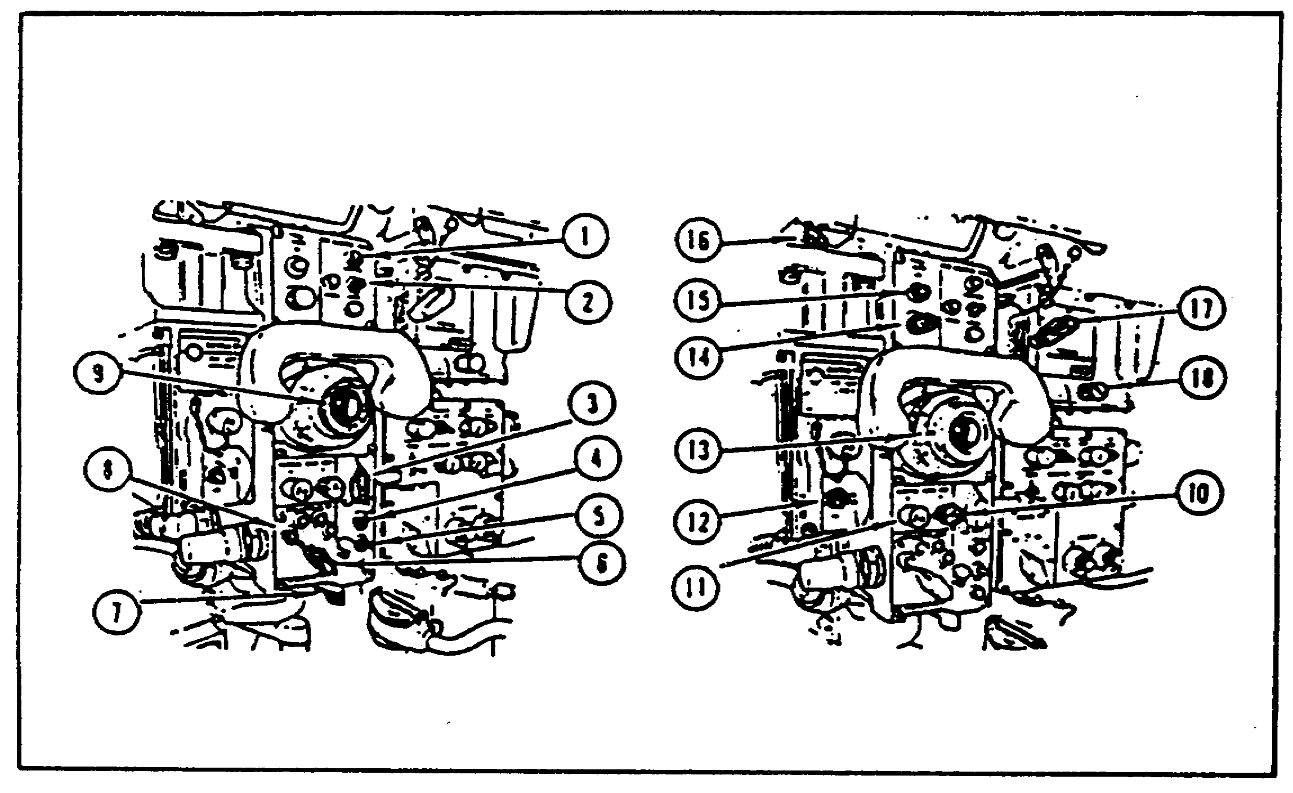

FIGURE 18. GUNNER'S PRIMARY SIGHT
(GPS) COMPONENTS.

Second Requirement

(1) Name the fire control modes controlled from the gunner's primary sight (GPS).

(2) After turret power is turned on, how long does it take the normal fire control mode to work?

(3) What do the four symbols in the following GPS view represent?

26

PRINC. OF GPS AND THERMAL SIGHT - OD0472 - LESSON 1/PE 1

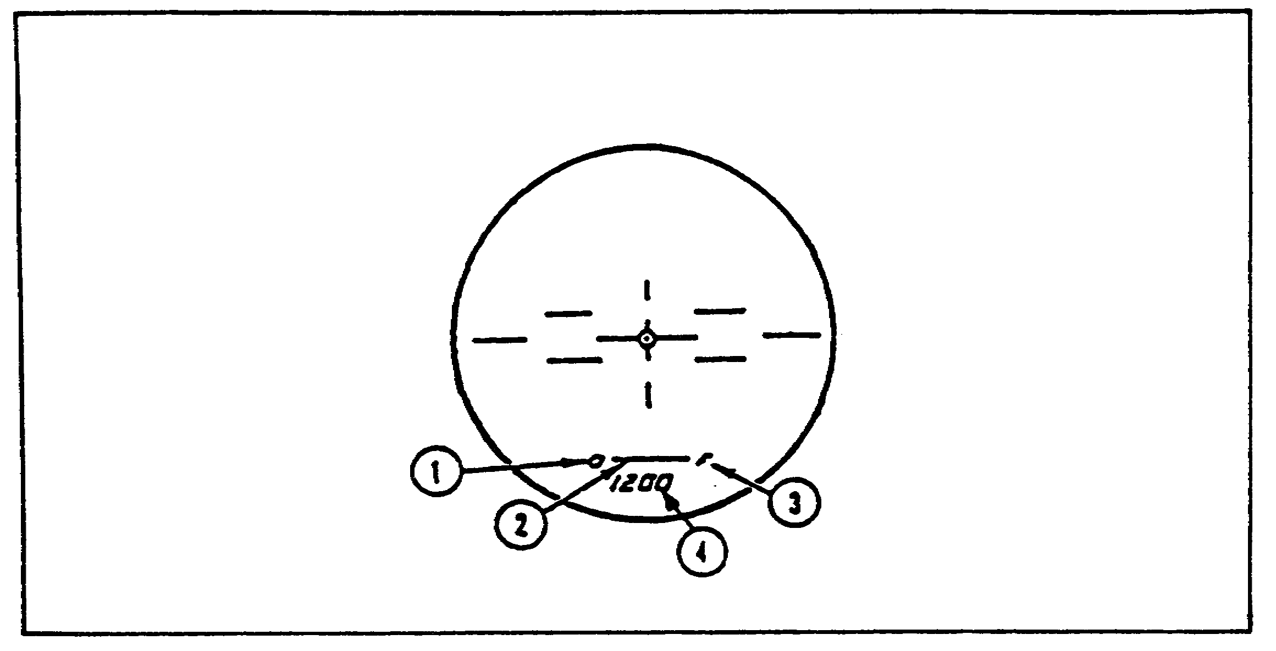

FIGURE 19. TYPICAL GPS VIEW.

(4) What is 3X magnification used for in the GPS?

(5) What allows the gunner to focus the image in the GPS eyepiece?

(6) Which ballistic door(s) must be open to use the laser rangefinder (LRF) ?

(7) The LRF can be hazardous to unprotected personnel. What is the primary safety precaution to be taken when operating the LRF, and what is its hazardous range?

(8) In which channel is the defroster, day or night optics?

Third Requirement

(1) What tells the gunner that the thermal receiver unit is operating?

(2) What controls the brightness of the range, ready-to-fire, multiple returns, and fire control malfunction indicators in the GPS?

(3) What image is produced when the POLARITY switch on the thermal imaging system (TIS) is set to WHITE HOT?

(4) To use the LRF with the TIS, which ballistic door(s) must be opened: day, night, or both?

27

PRINC. OF GPS AND THERMAL SIGHT - OD0472 - LESSON 1/PE 1

(5) When performing a TIS checkout, the main gun must be laid on a target at least how far from the tank?

(6) In normal operation, the TIS is set to STBY (standby) before trying to operate the system. This allows the system to cool down and receive thermal images. When can the TIS be turned on without having to wait for a system cool down and TRU READY light?

28

PRINC. OF GPS AND THERMAL SIGHT - OD0472 - LESSON 1/PE 1

LESSON 1. PRACTICAL EXERCISE - ANSWERS

First Requirement

(1) FIRE CONTROL MODE light

(2) FIRE CONTROL MODE switch

(3) FLTR/CLEAR/SHTR switch

(4) GUN SELECT light

(5) GUN SELECT switch

(6) AMMUNITION SELECT switch

(7) MAGNIFICATION lever

(8) AMMUNITION SELECT light

(9) Gunner's GPS eyepiece

(10) NORMAL MODE DRIFT EL (elevation) knob

(11) NORMAL MODE DRIFT AZ (azimuth) knob

(12) LRF RANGE switch

(13) Diopter adjustment

(14) PANEL LIGHTS knob

(15) PANEL LIGHTS TEST button

(16) MRS OUT/IN lever

(17) THERMAL MAGNIFICATION lever

(18) FOCUS knob

Second Requirement

(1) Normal, emergency, manual.

(2) 30 seconds.

(3) (a) Ready-to-fire

(b) Multiple returns

29

PRINC. OF GPS AND THERMAL SIGHT - OD0472 - LESSON 1/PE 1

(c) Fire control malfunction

(d) Target range 1200 meters

(4) Observing the sector and locating possible targets.

(5) Diopter adjustment.

(6) Day ballistic door.

(7) Treat the LRF as a direct fire weapon with a hazardous range of 8000 meters.

(8) Day optics channel.

Third Requirement

(1) The TRU READY light glows green; this takes approximately five to 15 minutes after placing the THERMAL MODE switch in STBY.

(2) The TIS SYMBOLS knob.

(3) The target image is light on a dark background.

(4) Both ballistic doors must be open to use the LRF with the TIS.

(5) 1000 meters.

(6) In a combat situation when immediate target engagement is necessary.

30

PRINC. OF GPS AND THERMAL SIGHT - OD0472 - LESSON 1/REFERENCES

REFERENCES

31

PRINC. OF GPS AND THERMAL SIGHT - OD0472 - REFERENCES

REFERENCES

The following documents were used as resource materials in developing this subcourse:

TM 9-2350-255-10-1
TM 9-2350-255-10-2
TM 9-2350-255-20-2-2-2

32

